5.0 Testing and Evaluation:

For this exercise we were tasked at gathering information from players about their thoughts on a game we chose.

The game the group chose was the game Sea Hero Quest, which was a game mainly aimed towards players that suffered from dementia and the main purpose of the game was to aid in dementia research.

Since this was already a finished product we couldn’t perform any software testing on the game, however with the questionnaire we made, we did receive feedback from four people regarding the game’s premise and gained both qualitative and quantitative data.

For our qualitative data, the questionnaire served as a good way of gaining opinions on the game. Out of the four respondents, three gave an answer to our question regarding the effectiveness of the game in helping with dementia research. Two of the three seemed to agree that the game was indeed effective, but there was one who personally found that it was not helpful at all, apart from providing comfort to those suffering the illness.

This was useful because it showed that the game still needed to improve in terms of communicating the purpose of the game to the players. However, on the other hand, opinions could also be biased. Although we were only working with four people, if we had more people the likelihood of biased opinions would have increased, which could have led to inaccurate data being gathered.

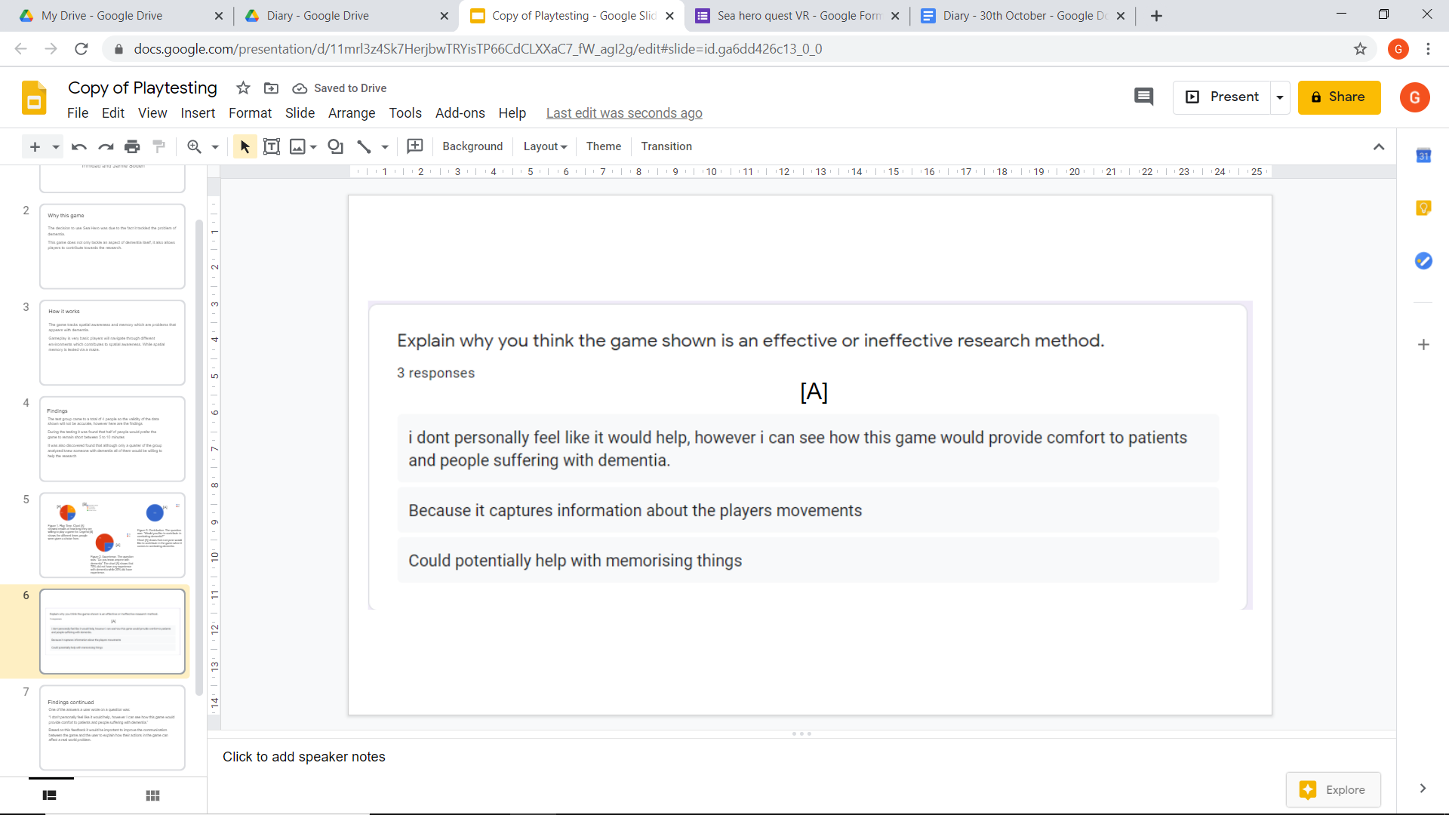

Figure 1. Responses. These are three responses [A] that we gained through the questionnaire that was released to everyone.

As part of the responses that were recorded, several charts also showed percentages of the respondents choices throughout the questionnaire. What’s useful about qualitative data was that it gave us a solid number on how many people chose certain answers. In comparison to subjective data, objective data such as the charts would have likely been subjected to any biases.

However, while qualitative data was useful, due to the fact we only had four respondents then the accuracy of the data was questionable. Earning only four answers does not give a wide scope of data and this can be problematic because having limited knowledge, could end up making the game not as accurate as it should be, this will then lead to the game becoming unsatisfactory for their clientèle.

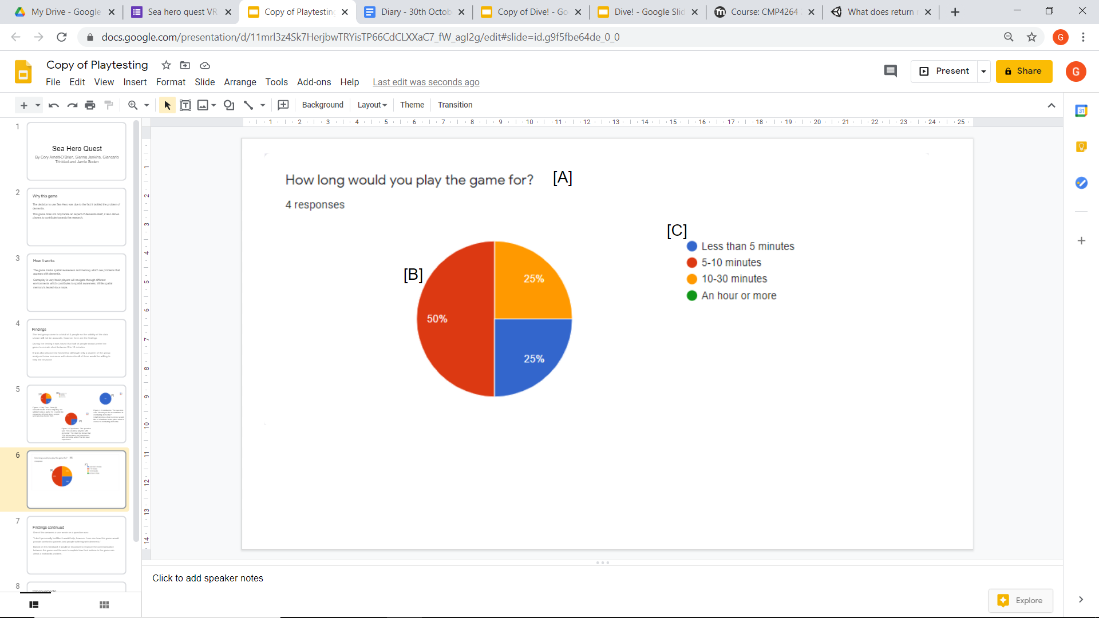

Figure 2. Charts. All charts follow a similar structure, a question [A] the chart with their percentages [B] and finally a legend that shows a distribution of the choices that were available.

In the future, I would personally implement similar tactics in order to gain general knowledge of what people would like in their games. For starters I would improve the methods in gathering data by asking a much larger demographic since it will allow me to see how my clients would like the game to be done. Another change I would implement would be the phrasing of certain questions, since the questionnaire made in the exercise had some questions that were missed out. What this signified was that the question was either unclear in conveying what was required or was poorly worded that it deterred participants from answering it.

However I would like to also improve on certain aspects of the questionnaire such as the phrasing of questions because at the end it showed that some questions missed out questions. This signified that either the way the questions were worded deterred people from answering them or was not clear enough to convey what was needed to be put down. Finally as mentioned before, a larger group of respondents would also be beneficial in future since it would expand the range of the information gained which can lead to more accurate results.